
UNIVERSITY OF HERTFORDSHIRE
School of Physics, Engineering and Computer Science

Final Project Report (FPR)
7PAM2002-0509: MSc Data Science Project
22-April-2026

“Lung Cancer Detection Using Deep Learning on CT Scan Images”

Name: Nallamaru vishnu Vardhan Reddy
Student ID: 24057022
Supervisor: Vidas Regelskis

ABSTRACT
This project presents a deep learning-based approach for lung cancer detection using CT scan images. Lung cancer is one of the leading causes of cancer-related deaths worldwide, making early and accurate diagnosis essential for improving patient survival rates. The study utilises the IQ-OTH/NCCD dataset, which contains CT scan images classified into three categories: benign, malignant, and normal.
Three deep learning models were developed and evaluated: a baseline Convolutional Neural Network (CNN), an improved CNN incorporating batch normalization, and a ResNet18 model. Image preprocessing techniques, including resizing and normalization, were applied, and class imbalance was addressed using class weighting.
The models were evaluated using accuracy and confusion matrices. The results show that the ResNet18 model achieved the best performance, with approximately 90% accuracy and strong detection of malignant cases. These findings demonstrate that deep learning techniques can effectively support automated lung cancer detection and have potential applications in clinical decision support systems.

Acknowledgement
I would like to express my deepest gratitude to my supervisor, Vidas Regelskis , for their guidance, insightful feedback, and encouragement throughout the course of this research. I am equally grateful to my professors and peers for their constructive suggestions and to my family for their unconditional support and motivation. Special thanks are also extended to the providers of the open-source weather datasets, without which this study would not have been possible.

MSc Final Project Declaration
This report is submitted in partial fulfilment of the requirement for the degree of Master of Science in Data Science at the University of Hertfordshire.
I have read the detailed guidance to students on academic integrity, misconduct and plagiarism information at Assessment Offences and Academic Misconduct and understand the University process of dealing with suspected cases of academic misconduct and the possible penalties, which could include failing the project or course.
I certify that the work submitted is my own and that any material derived or quoted from published or unpublished work of other persons has been duly acknowledged.
I did not use human participants in my MSc Project.
I hereby give permission for the report to be made available on module websites provided the source is acknowledged.
Student Name printed: Vishnu Vardhan Reddy Nallamaru
Student SRN number: 24057022

Table of Contents
ABSTRACT 2
Acknowledgement 3
MSc Final Project Declaration 4
CHAPTER 1 – INTRODUCTION 7
1.1 Background 7
1.2 Problem Statement 7
1.3 Aim 8
1.4 Objectives 8
1.5 Scope 9
1.6 Significance of the Study 9
Chapter 2: Literature Review 9
2.1 Overview of Lung Cancer Detection 9
2.2 Traditional Machine Learning Approaches 9
2.3 Deep Learning and CNN-Based Models 10
2.4 Transfer Learning and Advanced Architectures 10
2.5 Hybrid Deep Learning Models 10
2.6 Explainable AI in Medical Imaging 10
2.7 Challenges and Research Gaps 11
2.8 Research Gap and Contribution 11
Chapter 3: Methodology 11
3.1 Overview 11
3.2 Dataset Description 12
3.3 Data Preprocessing 13
3.4 Handling Class Imbalance 13
3.5 Model Development 14
3.5.1 Baseline CNN 14
3.5.2 Improved CNN 15
3.5.3 ResNet18 15
3.6 Training Configuration 15
3.7 Evaluation Metrics 15
3.8 Summary 16
Chapter 4: Results and Discussion 16
4.1 Overview 16
4.2 Baseline CNN Results 16
4.3 Improved CNN Results 17
4.4 ResNet18 Results 18
4.5 Comparative Analysis 18
4.6 Discussion 19
4.7 Misclassification Analysis 19
Chapter 5: Conclusion and Future Work 21
5.1 Conclusion 21
5.2 Limitations 21
5.3 Future Work 21
5.4 Summary 22
References 22
Appendix 22

CHAPTER 1 – INTRODUCTION

1.1 Background
Lung cancer is one of the most prevalent and life-threatening diseases worldwide, contributing significantly to global mortality rates. It remains a leading cause of cancer-related deaths due to late-stage diagnosis and limited early detection methods (Hammad et al., 2025). The disease is characterised by the uncontrolled growth of abnormal cells in the lung tissues, which can spread (metastasise) to other parts of the body if not detected early (Shatnawi et al., 2025). Early detection is critical, as the survival rate of patients diagnosed at an early stage is significantly higher compared to those diagnosed at advanced stages.
Risk factors such as smoking, air pollution, occupational exposure to hazardous substances, and genetic predisposition further contribute to the increasing incidence of lung cancer globally. Despite advancements in healthcare systems, early diagnosis remains a challenge due to the asymptomatic nature of the disease in its initial stages.
Medical imaging techniques, particularly Computed Tomography (CT) scans, play a crucial role in the diagnosis of lung cancer. CT scans provide high-resolution, cross-sectional images of the lungs, enabling clinicians to identify abnormalities such as pulmonary nodules, masses, and structural irregularities. Compared to traditional X-rays, CT imaging offers improved sensitivity and specificity in detecting small lesions, making it an essential tool in modern diagnostic workflows.
However, analysing CT scan images manually is a complex and time-consuming process that requires significant expertise. Radiologists must examine hundreds of image slices per patient, increasing cognitive load and the likelihood of oversight. The interpretation of these images is often subject to human error, inter-observer variability, and diagnostic delays (Hammad et al., 2025). These limitations highlight the need for more efficient and reliable diagnostic support systems.
With the rapid advancement of artificial intelligence (AI), particularly in the field of deep learning, there has been growing interest in developing automated systems for medical image analysis. Deep learning models, especially Convolutional Neural Networks (CNNs), have demonstrated strong capabilities in automatically extracting hierarchical features from medical images and identifying complex patterns that may not be easily visible to the human eye (Wang et al., 2025). These models eliminate the need for manual feature engineering and can learn directly from raw image data.
Furthermore, recent developments in transfer learning and pre-trained architectures such as ResNet, VGG, and EfficientNet have significantly improved performance in medical imaging tasks, especially when working with limited datasets. These approaches allow models trained on large-scale datasets to be adapted for specific medical applications, improving generalisation and reducing training time.
The integration of AI into medical imaging has the potential to transform clinical practice by enhancing diagnostic accuracy, reducing workload, and enabling early detection of diseases such as lung cancer. Consequently, research in this domain continues to grow, focusing on developing robust, interpretable, and clinically applicable deep learning models.

1.2 Problem Statement
Despite the availability of advanced medical imaging technologies, the accurate and timely detection of lung cancer remains a significant challenge. Manual interpretation of CT scan images is not only time-consuming but also highly dependent on the expertise of radiologists, which can lead to inconsistencies and variability in diagnosis (Hammad et al., 2025). In many cases, subtle patterns associated with early-stage cancer are difficult to detect, increasing the risk of misclassification and delayed treatment.
Another major issue is the exponential growth of medical imaging data, which places a considerable burden on healthcare systems. Radiologists are required to analyse large volumes of scans daily, which can lead to fatigue and reduced diagnostic efficiency. This situation underscores the need for automated systems that can assist in image analysis and prioritise critical cases.
From a machine learning perspective, challenges such as class imbalance, limited labelled data, and variability in imaging quality further complicate model development. In medical datasets, certain classes (e.g., benign or early-stage cancer cases) are often underrepresented, leading to biased models that may perform poorly in real-world scenarios (Shatnawi et al., 2025). Additionally, variations in CT scan acquisition parameters, noise levels, and patient anatomy introduce further complexity in achieving robust model performance.
Moreover, many existing studies focus primarily on model accuracy without adequately addressing issues such as generalisation, interpretability, and clinical applicability. For AI systems to be adopted in healthcare, they must not only be accurate but also reliable, transparent, and capable of supporting clinical decision-making.
Therefore, there is a critical need to develop an automated, accurate, and reliable deep learning-based system that can effectively detect and classify lung cancer from CT scan images while addressing challenges such as data imbalance, model generalisation, and real-world applicability.

1.3 Aim
This project aims to develop a deep learning-based system for the detection and classification of lung cancer using CT scan images.
Research Questions:
1. Can deep learning models accurately detect and classify lung cancer (normal, benign, malignant) using CT scan images from the IQ-OTH/NCCD dataset?
2. Which deep learning architecture (CNN, transfer learning models, or advanced vision models) provides the highest accuracy and reliability for medical image classification?
3. How effectively can pre-processing and data augmentation techniques improve classification performance on limited medical imaging data?

1.4 Objectives
- To preprocess CT scan images for model training
- To develop multiple deep learning models, including a baseline CNN, an improved CNN, and a ResNet18 model
- To handle class imbalance using class weighting techniques
- To evaluate model performance using accuracy and a confusion matrix
- To compare different models and identify the most effective approach

1.5 Scope
This project focuses on the classification of lung cancer using CT scan images into three categories: benign, malignant, and normal. The study is limited to the use of the IQ-OTH/NCCD dataset and deep learning techniques, specifically CNN-based architectures. The developed system is intended as a decision-support tool to assist clinicians and does not replace professional medical diagnosis.

1.6 Significance of the Study
This study is significant as it contributes to the growing field of AI-assisted medical diagnosis by exploring the application of deep learning techniques for lung cancer detection. The proposed system aims to support clinicians by providing a reliable and efficient tool for analysing CT scan images, thereby reducing diagnostic workload and improving decision-making.
By comparing multiple deep learning architectures, including baseline CNNs, improved CNNs, and transfer learning models such as ResNet18, this research provides insights into the most effective approaches for medical image classification. Additionally, the study addresses key challenges such as class imbalance and limited data through preprocessing and augmentation techniques.
The findings of this research may contribute to the development of more accurate and scalable diagnostic systems, ultimately aiding in early detection and improving patient outcomes. Furthermore, this work lays a foundation for future research in integrating AI models into real-world clinical environments.

Chapter 2: Literature Review

2.1 Overview of Lung Cancer Detection
Lung cancer detection has been a major area of research in medical imaging due to its high mortality rate and the critical importance of early diagnosis. Traditional diagnostic approaches rely heavily on radiologists to analyse Computed Tomography (CT) scan images. While effective, this process is time-consuming and subject to inter-observer variability, which can lead to inconsistencies in diagnosis. These limitations have motivated the exploration of artificial intelligence (AI)-based solutions to enhance diagnostic accuracy and efficiency (Hammad et al., 2025).

2.2 Traditional Machine Learning Approaches
Early research in lung cancer detection focused on conventional machine learning algorithms such as Support Vector Machines (SVM), Random Forest, and Logistic Regression. These methods required manual feature extraction techniques, where domain experts designed features based on texture, shape, and intensity.
Although these approaches achieved moderate success, their performance was highly dependent on the quality of handcrafted features. This limitation restricted their ability to capture complex and high-dimensional patterns present in medical images. Furthermore, these models often struggled with generalisation when applied to heterogeneous datasets, highlighting the need for more robust learning techniques (Wang et al., 2025).

2.3 Deep Learning and CNN-Based Models
The emergence of deep learning, particularly Convolutional Neural Networks (CNNs), has significantly advanced the field of medical image analysis. CNNs automatically learn hierarchical feature representations directly from raw image data, eliminating the need for manual feature engineering.
Numerous studies have demonstrated that CNN-based models outperform traditional machine learning approaches in lung cancer detection tasks. These models are particularly effective in identifying subtle abnormalities, such as small pulmonary nodules, which are often difficult to detect manually (Shatnawi et al., 2025).
However, despite their strong performance, CNN models require large amounts of labelled data for effective training. In medical imaging, such datasets are often limited, which can lead to overfitting and reduced generalisability.

2.4 Transfer Learning and Advanced Architectures
To address data limitations, recent studies have explored transfer learning techniques using pre-trained deep learning models such as VGG16, ResNet, InceptionV3, and EfficientNet. These models, trained on large-scale datasets, can be fine-tuned for medical imaging tasks, improving performance even with limited data.
Shatnawi et al. (2025) evaluated multiple deep learning architectures and reported high classification accuracy, with some models achieving near-perfect results. While these findings highlight the effectiveness of deep learning, such high accuracy levels raise concerns about potential overfitting, especially when evaluated on small or non-diverse datasets.
Additionally, deeper architectures often come with increased computational complexity, making them less suitable for real-time clinical applications or deployment in resource-constrained environments.

2.5 Hybrid Deep Learning Models
Recent research has also explored hybrid models that combine multiple deep learning techniques to improve performance. For instance, Wang et al. (2025) proposed a CNN-GRU model that integrates convolutional layers for spatial feature extraction with recurrent layers for capturing sequential dependencies.
This hybrid approach achieved an accuracy of 99.77%, demonstrating the potential benefits of combining different architectures. However, the increased model complexity results in higher computational costs and longer training times, which may limit practical implementation in clinical settings.

2.6 Explainable AI in Medical Imaging
One of the major challenges in deep learning-based healthcare systems is the lack of interpretability. Deep learning models are often considered “black boxes,” making it difficult for clinicians to understand how predictions are generated.
To address this issue, explainable AI (XAI) techniques have been introduced. Hammad et al. (2025) proposed a CNN-based model integrated with Grad-CAM, which highlights important regions in CT images influencing model predictions. Their model achieved an accuracy of 93.06% while providing visual explanations, thereby improving transparency and trust.
Despite these advancements, achieving a balance between model accuracy and interpretability remains an ongoing challenge in the field.

2.7 Challenges and Research Gaps
Despite significant progress, several challenges remain in deep learning-based lung cancer detection:
- Class Imbalance: Medical datasets often contain uneven class distributions, leading to biased model predictions.
- Limited Dataset Size: Many studies rely on small or curated datasets, reducing model generalisability.
- Lack of Standardisation: Variations in datasets, preprocessing techniques, and evaluation metrics make it difficult to compare results across studies.
- Overfitting Issues: Extremely high reported accuracies may not reflect real-world performance.
- Computational Complexity: Advanced models require significant computational resources, limiting practical deployment.
- Limited Clinical Validation: Many models are not tested in real-world clinical environments.
These limitations highlight the need for models that are not only accurate but also generalisable, efficient, and clinically applicable.

2.8 Research Gap and Contribution
Based on the reviewed literature, it is evident that while deep learning techniques have significantly improved lung cancer detection, there is still a gap in developing models that balance accuracy, generalisation, and computational efficiency.
Most existing studies focus primarily on maximising accuracy without adequately addressing challenges such as class imbalance and real-world applicability. Additionally, the comparative performance of different CNN architectures on the same dataset is not sufficiently explored.
Therefore, this project aims to develop and compare multiple deep learning models, including a baseline CNN, an improved CNN, and a ResNet18 model, using the IQ-OTH/NCCD dataset. The study also incorporates class weighting techniques to address data imbalance and evaluates models using consistent performance metrics to ensure fair comparison.

Chapter 3: Methodology

3.1 Overview
This chapter describes the methodology used to develop a deep learning-based system for lung cancer detection using CT scan images. The overall process includes dataset preparation, image preprocessing, handling class imbalance, model development, and performance evaluation. The workflow follows a structured pipeline to ensure reliable and consistent results.
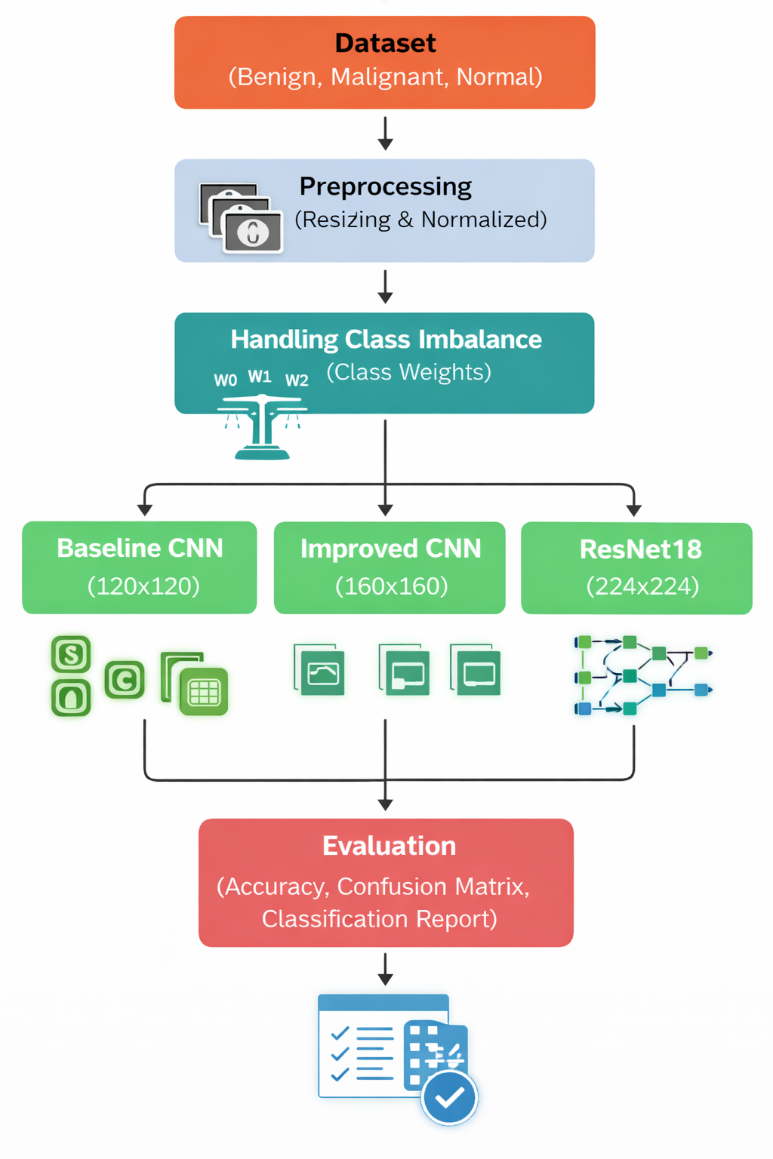
The above image illustrates the overall workflow of the proposed system. The process begins with the CT scan dataset consisting of three classes: benign, malignant, and normal. The images undergo preprocessing steps, including resizing and normalisation, followed by handling class imbalance using class weighting techniques. The processed data is then fed into three different deep learning models: a baseline CNN, an improved CNN, and a ResNet18 model. Finally, model performance is evaluated using metrics such as accuracy, confusion matrix, and classification report.

3.2 Dataset Description
The dataset used in this study consists of CT scan images categorised into three classes: benign, malignant, and normal. The dataset is inherently imbalanced, with malignant cases forming the majority class, followed by normal cases, while benign cases represent the minority class.
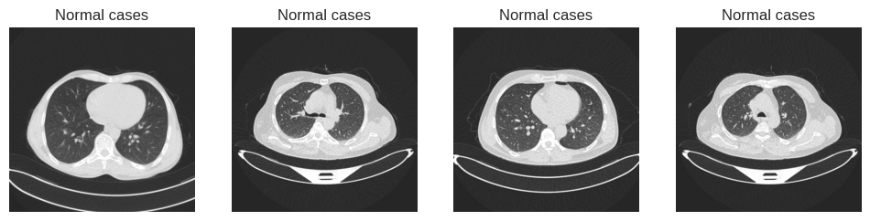
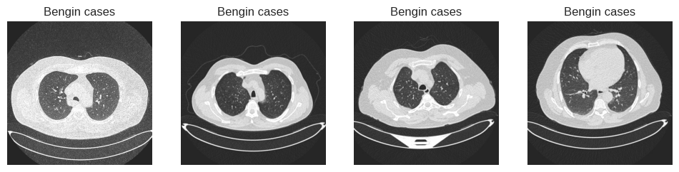
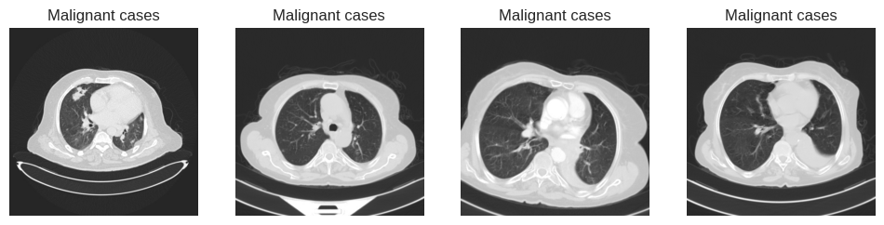
Class imbalance is a common challenge in medical imaging datasets and can significantly impact model performance by biasing predictions towards majority classes (Hammad et al., 2025). Therefore, appropriate techniques must be applied to ensure fair learning across all categories.

3.3 Data Preprocessing
Data preprocessing is a critical step in preparing images for deep learning models. All images were resized according to the input requirements of each model architecture. Specifically, the baseline CNN used an input size of 120 × 120 pixels, the improved CNN used 160 × 160 pixels, and the ResNet18 model used 224 × 224 pixels.
Resizing images to different resolutions allows models of varying complexity to capture different levels of spatial detail. Higher-resolution inputs enable deeper models to extract more fine-grained features, while smaller resolutions reduce computational cost.
In addition, all images were normalised to ensure a consistent pixel intensity distribution. Normalisation improves training stability, accelerates convergence, and enhances overall model performance (Wang et al., 2025).

3.4 Handling Class Imbalance
The dataset exhibits class imbalance, with significantly fewer benign cases compared to malignant and normal classes. This imbalance can lead to biased model predictions, where the model favours the majority classes.
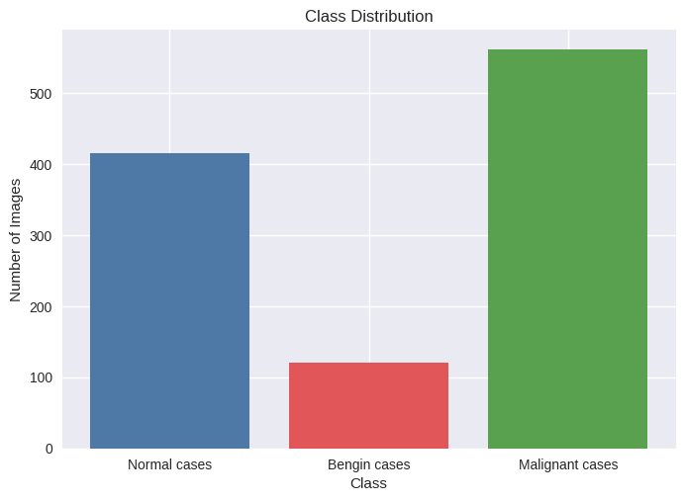
To address this issue, class weighting was applied during model training. Higher weights were assigned to the minority class (benign), ensuring that the model gives more importance to underrepresented samples. This approach improves the model’s ability to learn from all classes and enhances overall classification performance (Shatnawi et al., 2025).

3.5 Model Development
Three deep learning models were developed and evaluated in this study to compare their performance in lung cancer classification.

3.5.1 Baseline CNN
The baseline model is a simple Convolutional Neural Network consisting of three convolutional layers followed by ReLU activation and max pooling operations. The extracted features are passed through a fully connected layer with dropout to reduce overfitting. This model serves as a reference to evaluate the performance of more advanced architectures.
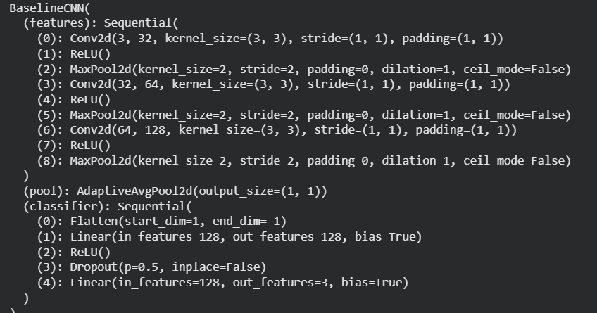

3.5.2 Improved CNN
The improved CNN extends the baseline architecture by increasing the network depth and incorporating batch normalization layers. Batch normalization helps stabilise the training process and improves convergence speed. Additionally, the model uses a larger input image size, allowing it to extract more detailed features from CT scan images.
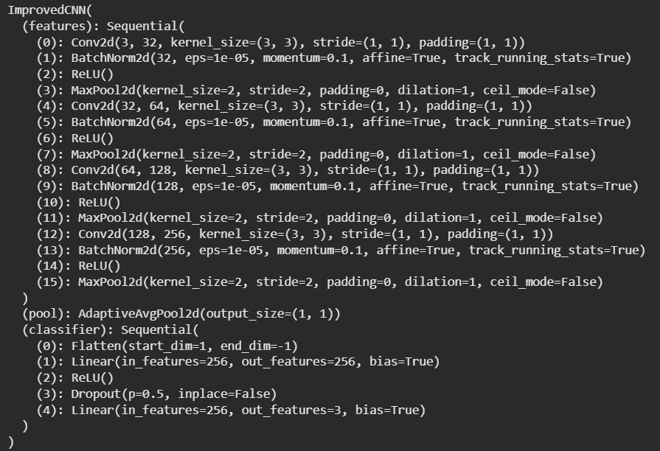

3.5.3 ResNet18
The ResNet18 model is a deep convolutional neural network that uses residual connections to overcome the vanishing gradient problem. These skip connections enable the model to learn deeper representations without degradation in performance. ResNet architectures have been widely used in medical image analysis due to their high accuracy and robustness (Hammad et al., 2025).

3.6 Training Configuration
All models were trained using a supervised learning approach for 10 epochs. During training, both training and validation accuracy were monitored to evaluate model performance and detect potential overfitting. Optimisation techniques such as gradient descent-based algorithms were used to update model weights during training (Wang et al., 2025).

3.7 Evaluation Metrics
The performance of the models was evaluated using multiple metrics, including accuracy, confusion matrix, and classification report. The classification report provides precision, recall, and F1-score for each class, offering a detailed analysis of model performance.
Accuracy measures the overall correctness of the model, while precision and recall provide insights into class-specific performance. The confusion matrix is particularly useful in identifying misclassification patterns and understanding model behaviour across different classes (Shatnawi et al., 2025).

3.8 Summary
This chapter presented the methodology used for lung cancer detection using CT scan images. The approach includes data preprocessing, class imbalance handling, and the development of three deep learning models. The next chapter presents the results and discussion of the model performance.

Chapter 4: Results and Discussion

4.1 Overview
This chapter presents the results obtained from the three deep learning models developed in this study: the baseline CNN, improved CNN, and ResNet18. The models are evaluated using accuracy, confusion matrices, and classification reports. A comparative analysis is also provided to assess the performance of each model.

4.2 Baseline CNN Results
The baseline CNN model was trained using an input size of 120 × 120 pixels. The training and validation accuracy over 10 epochs indicate gradual improvement; however, the model shows limited generalisation capability.
The overall accuracy achieved by the baseline model is approximately 75%. While this indicates moderate performance, the confusion matrix reveals significant limitations. The model fails to correctly classify benign cases, with a recall of 0.00, indicating that all benign samples are misclassified. In contrast, malignant cases are classified with relatively high accuracy, achieving a recall of 0.81, while normal cases achieve a recall of 0.91.
This imbalance in performance suggests that the model is biased towards the majority classes, particularly malignant and normal cases. The poor performance on benign cases can be attributed to class imbalance in the dataset, where benign samples are significantly underrepresented. Overall, the baseline CNN demonstrates underfitting and a limited ability to capture complex patterns in the data.
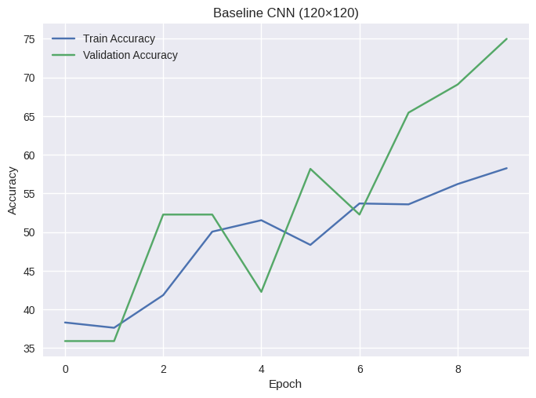 | 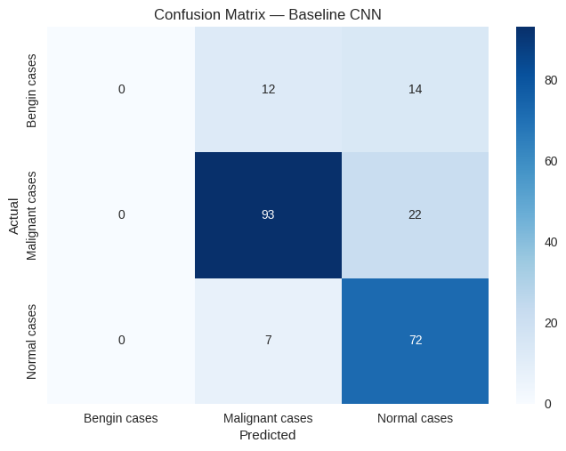

4.3 Improved CNN Results
The improved CNN model was developed by increasing the network depth and incorporating batch normalization, with an input size of 160 × 160 pixels. The training accuracy shows consistent improvement; however, the validation accuracy fluctuates across epochs, indicating instability during training.
The model achieves an overall accuracy of approximately 68%, which is lower than the baseline model. Despite architectural improvements, the confusion matrix shows that the model still struggles with class differentiation. Malignant cases are classified with high accuracy, achieving a recall of 1.00, but benign cases have very low recall (0.12), and normal cases show inconsistent performance.
These results indicate that while the improved CNN is capable of learning dominant patterns in the data, it still suffers from class imbalance and overfitting issues. The fluctuations in validation accuracy suggest that the model may not generalise well to unseen data.
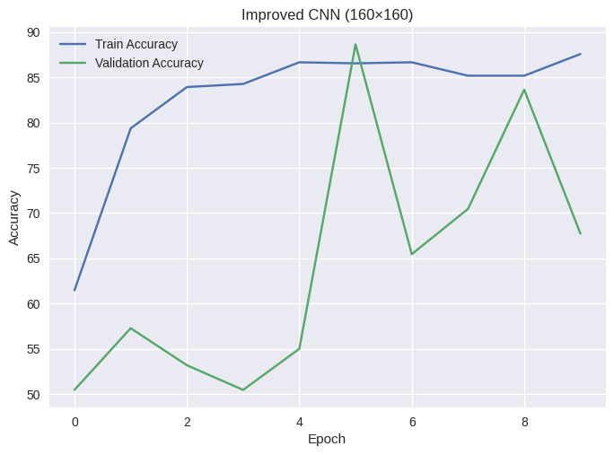 | 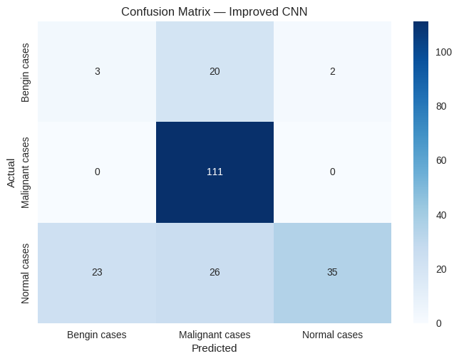

4.4 ResNet18 Results
The ResNet18 model was trained using an input size of 224 × 224 pixels and achieved the best performance among all models. The training and validation accuracy curves show stable learning behaviour with minimal overfitting.
The model achieves an overall accuracy of approximately 90%. The confusion matrix indicates excellent classification performance, particularly for malignant cases, which achieve a recall of 1.00. Normal cases are also classified effectively, with a recall of 0.95. Although benign cases still present some challenges, the recall improves to 0.32, which is significantly higher than the previous models.
The improved performance of ResNet18 can be attributed to its deeper architecture and the use of residual connections, which allow the model to learn more complex and meaningful features. This enables better generalisation and more accurate classification compared to the simpler CNN models.
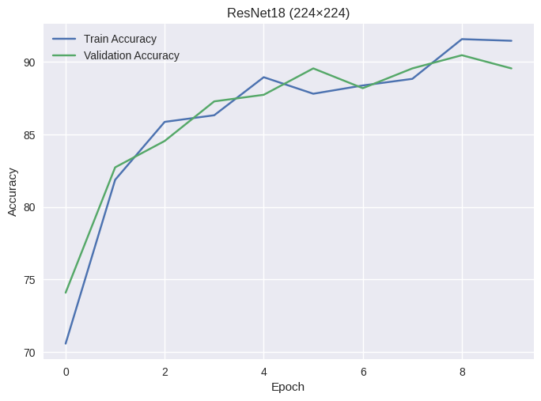 | 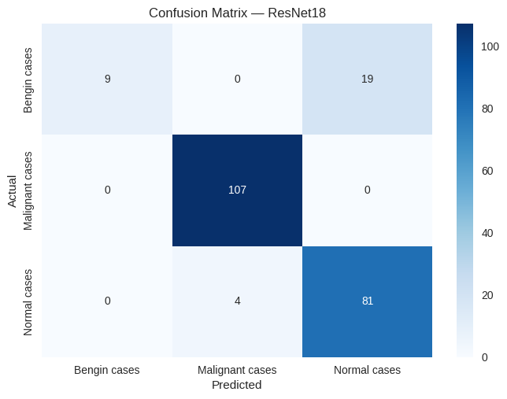

4.5 Comparative Analysis
A comparison of the three models highlights the impact of model complexity on performance. The baseline CNN provides moderate accuracy but fails to capture minority class features. The improved CNN introduces architectural enhancements but does not significantly improve performance due to instability and overfitting.
In contrast, the ResNet18 model demonstrates superior performance, achieving the highest accuracy and more balanced classification across classes. The results indicate that deeper architectures with residual connections are more effective for medical image classification tasks.
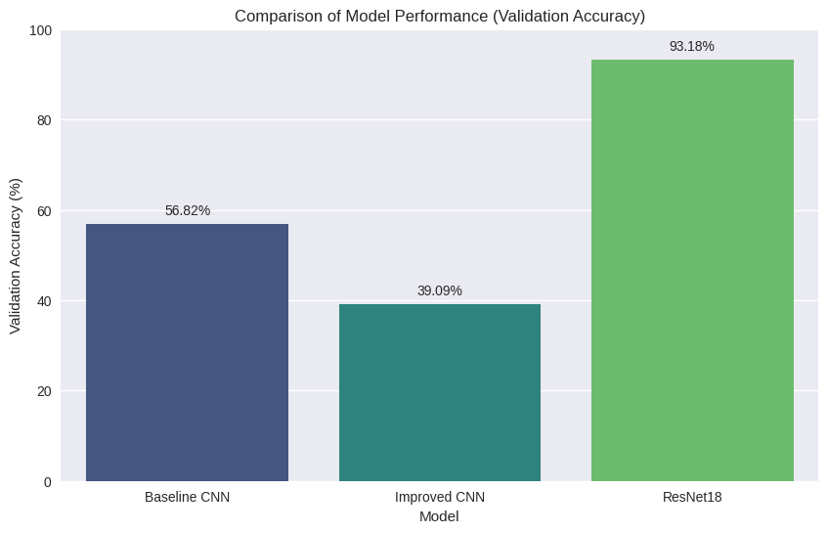
However, all models show some difficulty in classifying benign cases, which highlights the impact of class imbalance on model performance. This suggests that additional techniques, such as data augmentation or resampling, could further improve results.

4.6 Discussion
The results of this study demonstrate that deep learning models are effective for lung cancer detection using CT scan images. Performance improves as model complexity increases, with ResNet18 yielding the best results.
The findings are consistent with previous studies indicating that advanced architectures, such as ResNet, outperform traditional CNN models in medical imaging tasks (Hammad et al., 2025). However, the results also highlight ongoing challenges, particularly in handling imbalanced datasets and improving minority class detection.
Overall, the study confirms that deep learning-based approaches can significantly enhance lung cancer classification performance, while also identifying areas for further improvement.

4.7 Misclassification Analysis
To further evaluate model performance, a set of misclassified CT scan images is presented in Figure 4.X. These examples highlight cases where the model predictions differ from the true labels.
The figure shows that several benign cases are incorrectly classified as normal, while some normal cases are misclassified as malignant. This indicates that the model struggles to distinguish between subtle visual differences in certain CT scan images. In particular, benign cases are frequently misclassified, which is consistent with the low recall observed in the classification reports.
These misclassifications can be attributed to class imbalance, as the number of benign samples in the dataset is significantly lower compared to other classes. As a result, the model has limited exposure to benign patterns during training, leading to reduced performance for this class.
Additionally, some CT images may contain overlapping visual features between classes, making it difficult even for deep learning models to accurately differentiate them. This highlights the complexity of medical image classification tasks and the need for more robust feature extraction techniques.
Overall, the misclassification analysis provides deeper insight into model behaviour and supports the findings observed in the quantitative evaluation. It also emphasises the importance of improving minority class representation and model generalisation in future work.
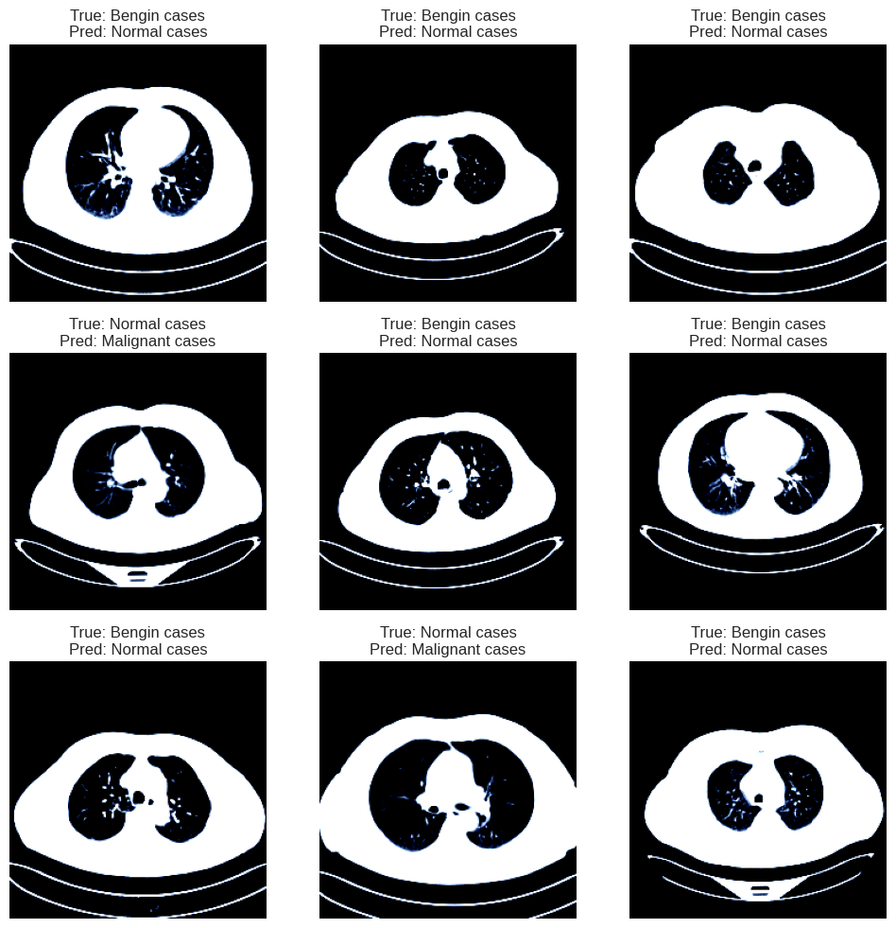

Chapter 5: Conclusion and Future Work

5.1 Conclusion
This project presented a deep learning-based approach for lung cancer detection using CT scan images. Three models were developed and evaluated, including a baseline CNN, an improved CNN, and a ResNet18 model. The objective was to classify CT scan images into benign, malignant, and normal categories while addressing challenges such as class imbalance and model generalisation.
The results demonstrate that model performance improves with increased architectural complexity. The baseline CNN achieved moderate performance but failed to effectively classify minority classes, particularly benign cases. The improved CNN introduced enhancements such as batch normalization and increased depth; however, it did not significantly improve overall accuracy and exhibited instability during validation.
Among the three models, ResNet18 achieved the best performance, with an accuracy of approximately 90%. The model demonstrated strong capability in detecting malignant cases, achieving near-perfect recall, which is critical in medical diagnosis. Additionally, it showed improved performance in classifying normal cases compared to the other models. However, the classification of benign cases remains a challenge due to dataset imbalance.
Overall, the findings of this study confirm that deep learning techniques, particularly advanced architectures such as ResNet, are highly effective for lung cancer detection using CT scan images. The results also highlight the importance of model selection, data preprocessing, and handling class imbalance in achieving reliable performance.

5.2 Limitations
Despite the promising results, this study has several limitations. The primary limitation is the class imbalance in the dataset, where benign cases are underrepresented. This affects the model’s ability to learn sufficient features for accurate classification of minority classes.
Another limitation is the relatively small dataset size, which may restrict the generalisability of the models to real-world clinical data. Additionally, the models were trained for a limited number of epochs, which may have impacted their ability to fully converge.
Furthermore, deep learning models require significant computational resources, which may limit their practical deployment in resource-constrained environments.

5.3 Future Work
Future research can focus on addressing the limitations identified in this study. One potential improvement is the use of data augmentation techniques to increase the representation of minority classes and improve model performance.
Another direction is the implementation of more advanced architectures, such as EfficientNet or transformer-based models, which may further enhance classification accuracy. Additionally, integrating explainable AI techniques, such as Grad-CAM, can improve model transparency and support clinical decision-making.
Further work can also involve training the models on larger and more diverse datasets to improve generalisation and robustness. Finally, the development of a real-time application or web-based system for lung cancer prediction can enhance the practical usability of the proposed approach in healthcare settings.

5.4 Summary
This chapter summarised the key findings of the study, discussed its limitations, and proposed directions for future research. The overall results highlight the potential of deep learning in improving lung cancer detection and supporting medical diagnosis.

References
Hammad, M., ElAffendi, M., Abd El-Latif, A.A., Ateya, A.A., Ali, G. and Plawiak, P. (2025) ‘Explainable AI for lung cancer detection via a custom CNN on CT images’, Scientific Reports, 15, Article number: 12707.
Wang, J., Haq, A.U., Afzal, N., Khan, S., Alsolai, H., Alanazi, S.M. and Zamani, A.T. (2025) ‘Developing an innovative lung cancer detection model for accurate diagnosis in AI healthcare systems’, Scientific Reports, 15, Article number: 22945.
Shatnawi, H., Alshorman, O., Bani Yaseen, A. and Alshorman, A. (2025) ‘Lung cancer detection using deep learning models’, International Journal of Advanced Computer Science and Applications, 16(1), pp. 1–10.
Alakwaa, W., Nassef, M. and Badr, A. (2017) ‘Lung cancer detection and classification with 3D convolutional neural networks’, Lung Cancer, 8(8), pp. 409–417.
Esteva, A., Kuprel, B., Novoa, R.A., Ko, J., Swetter, S.M., Blau, H.M. and Thrun, S. (2017) ‘Dermatologist-level classification of skin cancer with deep neural networks’, Nature, 542(7639), pp. 115–118.
Litjens, G., Kooi, T., Bejnordi, B.E., Setio, A.A.A., Ciompi, F., Ghafoorian, M., van der Laak, J.A.W.M., van Ginneken, B. and Sánchez, C.I. (2017) ‘A survey on deep learning in medical image analysis’, Medical Image Analysis, 42, pp. 60–88.

Appendix
# Import the drive module from google.colab
from google.colab import drive
# Mount Google Drive to the Colab environment
drive.mount('/content/drive')

# General utility and image processing libraries
import os
import random
import numpy as np
import matplotlib.pyplot as plt
import seaborn as sns
from PIL import Image
import cv2

# PyTorch core libraries for building and training neural networks
import torch
import torch.nn as nn
import torch.optim as optim

# Torchvision for datasets, image transformations, and pre-trained models
from torchvision import datasets, transforms, models
from torch.utils.data import DataLoader, random_split

# Scikit-learn for model evaluation metrics and collections for counting
from sklearn.metrics import confusion_matrix, classification_report
from collections import Counter

# Set the plotting style for better visualization aesthetics
plt.style.use('seaborn-v0_8')

# Determine the computational device (GPU if available, otherwise CPU)
device = torch.device("cuda" if torch.cuda.is_available() else "cpu")
print("Using device:", device)

# Define the path to the dataset stored in Google Drive
data_dir = "/content/drive/MyDrive/Lung cancer/The IQ-OTHNCCD lung cancer dataset"

# Define a list of class names (categories) present in the dataset
classes = ["Normal cases", "Bengin cases", "Malignant cases"]
# Print the list of defined classes
print(classes)

class_counts = {}
# Loop through each defined class to count images
for cls in classes:
# Construct the full path to the current class's folder
folder = os.path.join(data_dir, cls)
# Count the number of images (files) in the current class's folder
class_counts[cls] = len(os.listdir(folder))

# Create a bar plot to visualize the class distribution
plt.bar(class_counts.keys(), class_counts.values(),
color=['#4e79a7','#e15759','#59a14f'])

plt.title("Class Distribution")
plt.xlabel("Class")
plt.ylabel("Number of Images")

plt.show() # Display the plot

# Print the dictionary containing the counts for each class
print(class_counts)

#Function for sample class images
def show_samples(class_name, n=4):

folder = os.path.join(data_dir, class_name)
images = os.listdir(folder)

plt.figure(figsize=(12,4))

for i in range(n):

img = Image.open(os.path.join(folder, images[i]))

plt.subplot(1,n,i+1)
plt.imshow(img, cmap='gray')
plt.title(class_name)
plt.axis("off")

plt.show()

for cls in classes:
show_samples(cls)

def create_dataloaders(image_size):
# Define transformations for the training dataset
# These transformations include resizing, data augmentation (random horizontal flip, rotation, affine, color jitter),
# converting to a PyTorch tensor, and normalizing pixel values.
train_transform = transforms.Compose([
transforms.Resize((image_size, image_size)), # Resize images to the specified size
transforms.RandomHorizontalFlip(), # Randomly flip images horizontally for data augmentation
transforms.RandomRotation(15), # Randomly rotate images by up to 15 degrees
transforms.RandomAffine( # Apply random affine transformations
degrees=10,
translate=(0.05, 0.05),
scale=(0.9, 1.1)
),
transforms.ColorJitter( # Randomly change the brightness and contrast
brightness=0.1,
contrast=0.1
),
transforms.ToTensor(), # Convert images to PyTorch tensors
transforms.Normalize( # Normalize image tensors with mean and standard deviation
[0.485, 0.456, 0.406], # Mean values for R, G, B channels
[0.229, 0.224, 0.225] # Standard deviation values for R, G, B channels
)
])

# Define transformations for the validation dataset
# These transformations are typically simpler, involving only resizing,
# converting to a PyTorch tensor, and normalizing pixel values.
val_transform = transforms.Compose([
transforms.Resize((image_size, image_size)), # Resize images to the specified size
transforms.ToTensor(), # Convert images to PyTorch tensors
transforms.Normalize( # Normalize image tensors with mean and standard deviation
[0.485, 0.456, 0.406],
[0.229, 0.224, 0.225]
)
])

# Load the entire dataset using ImageFolder
# ImageFolder expects the dataset to be organized with subfolders for each class.
dataset = datasets.ImageFolder(root=data_dir)

# Split the dataset into training and validation sets
# 80% of the data is used for training, and 20% for validation.
train_size = int(0.8 * len(dataset))
val_size = len(dataset) - train_size

train_dataset, val_dataset = random_split(dataset,
[train_size, val_size])

# Apply the defined transformations to the respective datasets
# Note: the transform is applied to the 'dataset' attribute of the Subset returned by random_split
train_dataset.dataset.transform = train_transform
val_dataset.dataset.transform = val_transform

# Create DataLoaders for efficient batching and shuffling of data
train_loader = DataLoader(train_dataset,
batch_size=32, # Number of samples per batch
shuffle=True, # Shuffle data for training
num_workers=2) # Number of subprocesses to use for data loading

val_loader = DataLoader(val_dataset,
batch_size=32, # Number of samples per batch
shuffle=False, # Do not shuffle validation data
num_workers=2)

return train_loader, val_loader, dataset

# Calculate class weights to handle dataset imbalance
dataset = datasets.ImageFolder(root=data_dir)

targets = [label for _,label in dataset.samples]

class_counts = Counter(targets)

total_samples = sum(class_counts.values())

class_weights = []

for i in range(len(class_counts)):
class_weights.append(total_samples/class_counts[i])

class_weights = torch.tensor(class_weights).float().to(device)

print("Class weights:", class_weights)

train_loader_120, val_loader_120, dataset = create_dataloaders(120)

class BaselineCNN(nn.Module):
# Defines a basic Convolutional Neural Network (CNN) architecture.
# This model is designed for image classification tasks.

def __init__(self):
# Constructor for the BaselineCNN class.
# Initializes the layers and modules of the CNN.
super().__init__() # Call the constructor of the parent class (nn.Module)

# Feature extraction layers: A sequence of Conv2d, ReLU, and MaxPool2d layers
# to extract hierarchical features from the input images.
self.features = nn.Sequential(

# First convolutional block
nn.Conv2d(3, 32, 3, padding=1), # Input: 3 channels (RGB), Output: 32 feature maps, 3x3 kernel, 1-pixel padding
nn.ReLU(), # Rectified Linear Unit activation function (introduces non-linearity)
nn.MaxPool2d(2), # Max pooling layer (reduces spatial dimensions by a factor of 2)

# Second convolutional block
nn.Conv2d(32, 64, 3, padding=1), # Input: 32 feature maps, Output: 64 feature maps
nn.ReLU(), # ReLU activation
nn.MaxPool2d(2), # Max pooling

# Third convolutional block
nn.Conv2d(64, 128, 3, padding=1),# Input: 64 feature maps, Output: 128 feature maps
nn.ReLU(), # ReLU activation
nn.MaxPool2d(2) # Max pooling
)

# Adaptive average pooling layer
# Reduces the spatial dimensions of the feature maps to 1x1, making the output size fixed
# regardless of the input image size, before passing to the classifier.
self.pool = nn.AdaptiveAvgPool2d((1, 1))

# Classifier layers: A sequence of layers to classify the extracted features.
self.classifier = nn.Sequential(
nn.Flatten(), # Flattens the 3D feature maps (batch_size, channels, 1, 1) into a 1D vector (batch_size, channels)
nn.Linear(128, 128), # Fully connected linear layer: Input 128 features, Output 128 features
nn.ReLU(), # ReLU activation
nn.Dropout(0.5), # Dropout layer (randomly sets 50% of inputs to zero during training to prevent overfitting)
nn.Linear(128, 3) # Output linear layer: Input 128 features, Output 3 features (corresponding to 3 classes)
)

def forward(self, x):
# Defines the forward pass of the network.
# This method dictates how input 'x' flows through the layers.

x = self.features(x) # Pass input through the feature extraction layers
x = self.pool(x) # Apply adaptive average pooling
x = self.classifier(x) # Pass pooled features through the classifier to get class scores (logits)

return x # Return the output logits

model1 = BaselineCNN().to(device)

criterion = nn.CrossEntropyLoss(weight=class_weights)

optimizer = optim.Adam(model1.parameters(), lr=0.001)

print(model1)

def train_model(model,train_loader,val_loader,epochs=10):

train_acc=[]
val_acc=[]

# Loop through each epoch
for epoch in range(epochs):

model.train() # Set model to training mode
correct=0
total=0

# Training loop
for images,labels in train_loader:

images=images.to(device)
labels=labels.to(device)

optimizer.zero_grad() # Zero the gradients

outputs=model(images)

loss=criterion(outputs,labels) # Calculate loss

loss.backward() # Backpropagate the loss

optimizer.step() # Update model parameters

_,preds=torch.max(outputs,1)

total+=labels.size(0)
correct+=(preds==labels).sum().item()

train_accuracy=100*correct/total
train_acc.append(train_accuracy)

model.eval() # Set model to evaluation mode
correct=0
total=0

# Validation loop (no gradient calculation)
with torch.no_grad():

for images,labels in val_loader:

images=images.to(device)
labels=labels.to(device)

outputs=model(images)

_,preds=torch.max(outputs,1)

total+=labels.size(0)
correct+=(preds==labels).sum().item()

val_accuracy=100*correct/total
val_acc.append(val_accuracy)

print(f"Epoch {epoch+1}/{epochs} | Train {train_accuracy:.2f}% | Val {val_accuracy:.2f}%")

return train_acc,val_acc

# Train the BaselineCNN model with 120x120 images for 10 epochs
train_acc_120,val_acc_120 = train_model(
model1,
train_loader_120,
val_loader_120,
epochs=10
)

# The training and validation accuracy of the Baseline CNN model plot.
plt.plot(train_acc_120,label="Train Accuracy")
plt.plot(val_acc_120,label="Validation Accuracy")

plt.xlabel("Epoch")
plt.ylabel("Accuracy")
plt.title("Baseline CNN (120×120)")

plt.legend()
plt.show()

# Baseline model confusion matrix
model1.eval()

all_preds=[]
all_labels=[]

with torch.no_grad():

for images,labels in val_loader_120:

images=images.to(device)

outputs=model1(images)

_,preds=torch.max(outputs,1)

all_preds.extend(preds.cpu().numpy())
all_labels.extend(labels.numpy())

cm = confusion_matrix(all_labels,all_preds)

sns.heatmap(cm,
annot=True,
fmt="d",
cmap="Blues",
xticklabels=dataset.classes,
yticklabels=dataset.classes)

plt.xlabel("Predicted")
plt.ylabel("Actual")
plt.title("Confusion Matrix — Baseline CNN")

plt.show()

#classification report for baseline cnn model
print(classification_report(all_labels,
all_preds,
target_names=dataset.classes))

"""Improved CNN"""

train_loader_160, val_loader_160, dataset = create_dataloaders(160)

class ImprovedCNN(nn.Module):
# Defines an improved Convolutional Neural Network (CNN) architecture
# with Batch Normalization layers for better training stability and performance.

def __init__(self):
# Constructor for the ImprovedCNN class.
# Initializes the layers and modules of the CNN.
super().__init__() # Call the constructor of the parent class (nn.Module)

# Feature extraction layers: A sequence of Conv2d, BatchNorm2d, ReLU, and MaxPool2d layers
# to extract hierarchical features from the input images.
self.features = nn.Sequential(
# First convolutional block
nn.Conv2d(3, 32, 3, padding=1), # Input: 3 channels (RGB), Output: 32 feature maps, 3x3 kernel, 1-pixel padding
nn.BatchNorm2d(32), # Batch Normalization layer
nn.ReLU(), # Rectified Linear Unit activation function (introduces non-linearity)
nn.MaxPool2d(2), # Max pooling layer (reduces spatial dimensions by a factor of 2)

# Second convolutional block
nn.Conv2d(32, 64, 3, padding=1), # Input: 32 feature maps, Output: 64 feature maps
nn.BatchNorm2d(64), # Batch Normalization layer
nn.ReLU(), # ReLU activation
nn.MaxPool2d(2), # Max pooling

# Third convolutional block
nn.Conv2d(64, 128, 3, padding=1),# Input: 64 feature maps, Output: 128 feature maps
nn.BatchNorm2d(128), # Batch Normalization layer
nn.ReLU(), # ReLU activation
nn.MaxPool2d(2), # Max pooling

# Fourth convolutional block
nn.Conv2d(128, 256, 3, padding=1),# Input: 128 feature maps, Output: 256 feature maps
nn.BatchNorm2d(256), # Batch Normalization layer
nn.ReLU(), # ReLU activation
nn.MaxPool2d(2) # Max pooling
)

# Adaptive average pooling layer
# Reduces the spatial dimensions of the feature maps to 1x1, making the output size fixed
# regardless of the input image size, before passing to the classifier.
self.pool = nn.AdaptiveAvgPool2d((1,1))

# Classifier layers: A sequence of layers to classify the extracted features.
self.classifier = nn.Sequential(
nn.Flatten(), # Flattens the 3D feature maps (batch_size, channels, 1, 1) into a 1D vector (batch_size, channels)
nn.Linear(256, 256), # Fully connected linear layer: Input 256 features, Output 256 features
nn.ReLU(), # ReLU activation
nn.Dropout(0.5), # Dropout layer (randomly sets 50% of inputs to zero during training to prevent overfitting)
nn.Linear(256, 3) # Output linear layer: Input 256 features, Output 3 features (corresponding to 3 classes)
)

def forward(self, x):
# Defines the forward pass of the network.
# This method dictates how input 'x' flows through the layers.

x = self.features(x) # Pass input through the feature extraction layers
x = self.pool(x) # Apply adaptive average pooling
x = self.classifier(x) # Pass pooled features through the classifier to get class scores (logits)

return x # Return the output logits

# Initialize the ImprovedCNN model, define loss, optimizer, and learning rate scheduler.
model2 = ImprovedCNN().to(device)

criterion = nn.CrossEntropyLoss()

optimizer = optim.Adam(model2.parameters(), lr=0.001)

scheduler = torch.optim.lr_scheduler.StepLR(
optimizer,
step_size=5,
gamma=0.5
)

print(model2)

# Train the ImprovedCNN model with 160x160 images for 10 epochs
train_acc_160, val_acc_160 = train_model(
model2,
train_loader_160,
val_loader_160,
epochs=10
)

# The training and validation accuracy of the Improved CNN model plot.
plt.plot(train_acc_160,label="Train Accuracy")
plt.plot(val_acc_160,label="Validation Accuracy")

plt.xlabel("Epoch")
plt.ylabel("Accuracy")
plt.title("Improved CNN (160×160)")

plt.legend()
plt.show()

#Improved CNN confusion matrix.
model2.eval()

all_preds=[]
all_labels=[]

with torch.no_grad():

for images,labels in val_loader_160:

images=images.to(device)

outputs=model2(images)

_,preds=torch.max(outputs,1)

all_preds.extend(preds.cpu().numpy())
all_labels.extend(labels.numpy())

cm = confusion_matrix(all_labels,all_preds)

sns.heatmap(cm,
annot=True,
fmt="d",
cmap="Blues",
xticklabels=dataset.classes,
yticklabels=dataset.classes)

plt.xlabel("Predicted")
plt.ylabel("Actual")
plt.title("Confusion Matrix — Improved CNN")

plt.show()

# classification report for imroved cnn model
print(classification_report(
all_labels,
all_preds,
target_names=dataset.classes
))

"""MODEL -3

"""

train_loader_224, val_loader_224, dataset = create_dataloaders(224)

from torchvision import models

# Load a pre-trained ResNet18 model for transfer learning.
model3 = models.resnet18(pretrained=True)

for param in model3.parameters():
param.requires_grad = False

num_features = model3.fc.in_features # Get the number of input features for the original final layer

# Reassign the final fully connected layer (fc) to a new linear layer
# This new layer will have 'num_features' input features and '3' output features
# corresponding to the 3 classes in our dataset.
model3.fc = nn.Linear(num_features, 3)

# Move the entire model to the specified device (GPU if available, else CPU)
model3 = model3.to(device)

print(model3)

criterion = nn.CrossEntropyLoss() # Define the loss function: CrossEntropyLoss is suitable for multi-class classification

# Define the optimizer: Adam optimizer is used to update only the parameters of the newly added final layer (model3.fc),
# as the rest of the pre-trained ResNet18 layers are frozen (param.requires_grad = False).
optimizer = optim.Adam(model3.fc.parameters(), lr=0.001)

train_acc_224, val_acc_224 = train_model(
model3,
train_loader_224,
val_loader_224,
epochs=10
)

# Plot the training and validation accuracy of the ResNet18 model.
plt.plot(train_acc_224,label="Train Accuracy")
plt.plot(val_acc_224,label="Validation Accuracy")

plt.xlabel("Epoch")
plt.ylabel("Accuracy")
plt.title("ResNet18 (224×224)")

plt.legend()
plt.show()

model3.eval()

all_preds=[]
all_labels=[]

with torch.no_grad():

for images,labels in val_loader_224:

images=images.to(device)

outputs=model3(images)

_,preds=torch.max(outputs,1)

all_preds.extend(preds.cpu().numpy())
all_labels.extend(labels.numpy())

cm = confusion_matrix(all_labels,all_preds)

sns.heatmap(cm,
annot=True,
fmt="d",
cmap="Blues",
xticklabels=dataset.classes,
yticklabels=dataset.classes)

plt.xlabel("Predicted")
plt.ylabel("Actual")
plt.title("Confusion Matrix — ResNet18") # Evaluate and visualize the ResNet18 model's confusion matrix.

plt.show()

print(classification_report(
all_labels,
all_preds,
target_names=dataset.classes
))

"""MISSCLASIFIED IMAGES"""

misclassified_images = []
misclassified_labels = []
misclassified_preds = []

model3.eval()

with torch.no_grad():

for images, labels in val_loader_224:

images = images.to(device)

outputs = model3(images)

_, preds = torch.max(outputs, 1)

for i in range(len(labels)):

if preds[i] != labels[i]:

misclassified_images.append(images[i].cpu())
misclassified_labels.append(labels[i].cpu())
misclassified_preds.append(preds[i].cpu())

import matplotlib.pyplot as plt # Import the matplotlib library for plotting

class_names = dataset.classes # Get the class names from the dataset for display

num_images = min(9, len(misclassified_images)) # Determine the number of images to display (max 9)

plt.figure(figsize=(12,12)) # Create a figure with a specified size for the plot

for i in range(num_images):

img = misclassified_images[i]

# Permute the dimensions and convert to a NumPy array for matplotlib display
# (from CxHxW to HxWxC, and then to NumPy)
img = img.permute(1,2,0).numpy()

plt.subplot(3,3,i+1) # Create a subplot in a 3x3 grid
plt.imshow(img) # Display the image

true_label = class_names[misclassified_labels[i]] # Get the actual class name
pred_label = class_names[misclassified_preds[i]] # Get the predicted class name

# Set the title for each subplot showing true and predicted labels
plt.title(f"True: {true_label}\nPred: {pred_label}")
plt.axis("off") # Hide the axes for cleaner image display

plt.show() # Display the complete plot with all subplots

val_transform = transforms.Compose([
transforms.Resize((224, 224)),
transforms.ToTensor(),
transforms.Normalize(
[0.485, 0.456, 0.406],
[0.229, 0.224, 0.225]
)
])

def predict_image(image_path, model, transform, class_names, device):
model.eval() # Set the model to evaluation mode
image = Image.open(image_path).convert('RGB')
image_tensor = transform(image).unsqueeze(0)
image_tensor = image_tensor.to(device)

with torch.no_grad():
outputs = model(image_tensor)
_, predicted = torch.max(outputs, 1)

return class_names[predicted.item()]

# Example usage:
# Get class names from the dataset.
class_names = dataset.classes

# Find an example image path from the dataset
example_image_path = os.path.join(data_dir, 'Normal cases', os.listdir(os.path.join(data_dir, 'Normal cases'))[0])

predicted_class = predict_image(example_image_path, model3, val_transform, class_names, device)
print(f"The predicted class for {example_image_path} is: {predicted_class}")

# Get the final validation accuracy for each model
final_accuracy_model1 = val_acc_120[-1]
final_accuracy_model2 = val_acc_160[-1]
final_accuracy_model3 = val_acc_224[-1]

# Define model names and their corresponding accuracies
models = ['Baseline CNN', 'Improved CNN', 'ResNet18']
accuracies = [final_accuracy_model1, final_accuracy_model2, final_accuracy_model3]

# Create a figure for the bar plot
plt.figure(figsize=(10, 6))
# Generate the bar plot
bars = sns.barplot(x=models, y=accuracies, hue=models, palette='viridis', legend=False)
plt.title('Comparison of Model Performance (Validation Accuracy)') # Set plot title
plt.xlabel('Model') # Set x-axis label
plt.ylabel('Validation Accuracy (%)') # Set y-axis label
plt.ylim(0, 100) # Set y-axis limit from 0 to 100%

# Add accuracy values on top of each bar
for bar in bars.patches:
bars.annotate(f'{bar.get_height():.2f}%',
(bar.get_x() + bar.get_width() / 2, bar.get_height()),
ha='center', va='bottom',
xytext=(0, 5),
textcoords='offset points')

plt.show() # Display the plot

# Print the final validation accuracies for each model
print(f"Baseline CNN (120x120) Final Validation Accuracy: {final_accuracy_model1:.2f}%")
print(f"Improved CNN (160x160) Final Validation Accuracy: {final_accuracy_model2:.2f}%")
print(f"ResNet18 (224x224) Final Validation Accuracy: {final_accuracy_model3:.2f}%")

